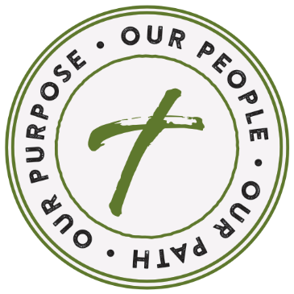
PARISH NAME
PARISH ADDRESS
CITY STATE, ZIP

Date

ADDRESSEE
ADDRESS
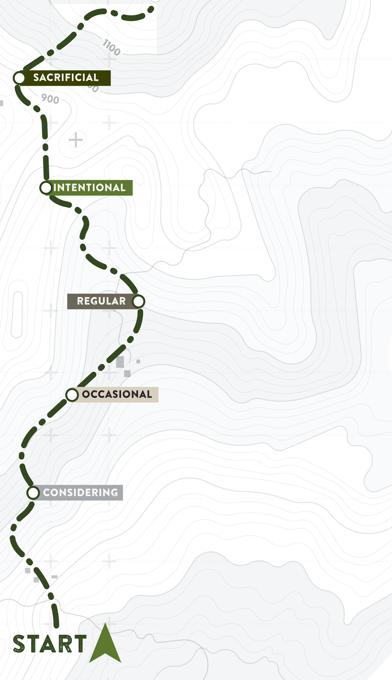
CITY, STATE ZIP

Dear SALUTATION,
It is with heartfelt gratitude that I thank you for your commitment to Our Parish. Whether you are making sacrificial donations, volunteering your time or attending weekly Mass, your presence and participation are a blessing.

This past year has been filled with unexpected twists and turns. Through it all, we have an opportunity before us to pave our path forward. We recently presented our Annual Report which shows the financial state of our parish. While we experienced an increase/decrease/stayed about the same as last year, we still do not know the full extent or duration of the impact of the Covid-19 (Coronavirus) pandemic. This certainly leaves us all still thinking about what tomorrow may bring and how it will effect us, our families and our parish. Our priority is always the health and safety of our parishioners, but we also want to be mindful that our ministries and programs continue to be funded. In the coming year, our parish will focus on evangelization, faith formation and restoring parts of our church building. However, with all of this, we trust in the grace and power of Jesus to help us persevere through these challenges, for we know with God all things are possible.

In the coming weeks, we will be highlighting ways your offertory contributions make a positive impact. Please take a moment to reflect on where you are on your personal path and how you might move forward, with even a small step. Perhaps you are an occasional participant who could commit to making a gift online. Or, maybe you are a faithful regular donor who could make a sacrificial gift by going above and beyond what you’ve given before.

Now more than ever, we are called to offer what we are able so we can sustain our parish and our ministries. If your finances allow, I encourage you to renew or strengthen your commitment to our shared purpose with even a small increase in your weekly offering. Please also consider filling out and returning the enclosed flyer with ways you are inspired by our parish and why you choose to participate or visit opfaob.com to share your comments online.

My prayers remain with you and your families. Thank you for being part of our Parish and for your kind consideration. I am humbled by and grateful for your support.

Yours in Christ,
SIGNATURE
Name, Pastor

